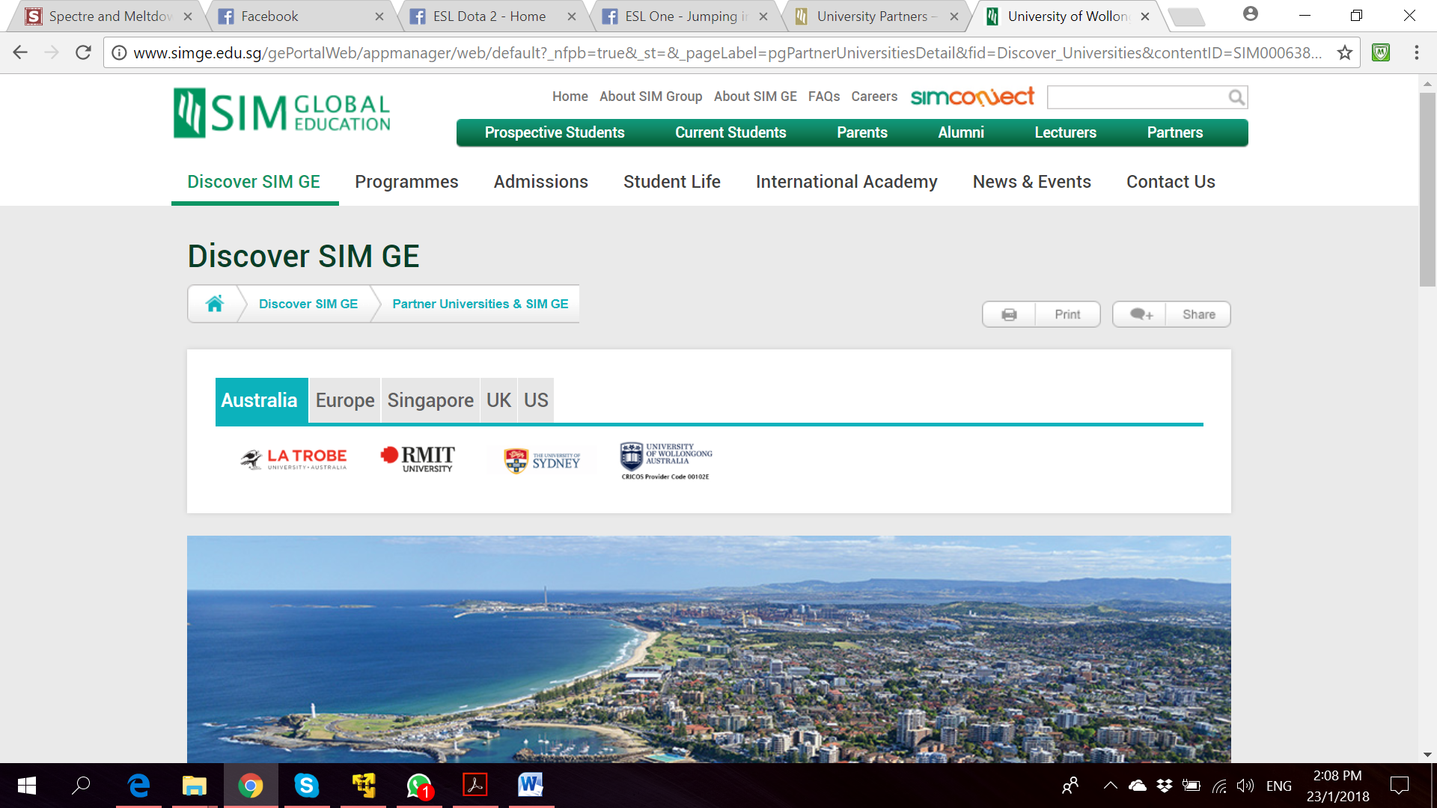

**Bachelor of Computer Science**

**(Digital System Security)**

CSCI321 – Final Year Project

System Architecture Document

**Project Particulars**

|  |  |
| --- | --- |
| Supervisor | Dr Ta Nguyen Binh Duong |
| Project Group | SS18/1F |
| Project Title | Two Factor Authentication |

**Project Team’s Particulars**

|  |  |  |
| --- | --- | --- |
| Student Number | Student Name | Email Address |
| 5363536 | Koh Hong Wei | hwkoh003@mymail.sim.edu.sg |
| 5710923 | Chua Han Ming Adler | hmachua002@mymail.sim.edu.sg |
| 5711356 | Ong Wei Hao | whong012@mymail.sim.edu.sg |



**A secure file locking application**

Table of Contents

1. Introduction 5

2. Software Architecture 5

2.1 Architecture Overview 5

2.2 Architecture Design Patter 5

2.2.1 Why MVP pattern? 5

2.3 Logical Architecture Overview 5

2.3.1 Layer Diagram 5

2.3.2 Logical Design Qualities 5

2.4 Physical Architecture 5

2.4.1 Physical Architecture Overview 5

2.4.2 Deployment Diagram 5

3. System Architecture Qualities 5

3.1 Extensibility 5

3.2 Maintainability 5

3.3 Performance 5

3.4 Usability 5

3.5 Compatibility 5

3.6 Security 5

4. Database Design 5

5. Appendix A: Glossary 5

6. References 5

# Introduction

This document describes the architecture of go2FA system.

It describes:

* General description of the system
* Logical architecture of the software, layers and top-level components
* Physical architecture of the hardware on which runs the software
* Justification of technical choices made
* Traceability between architecture and system requirements

# Software Architecture

## Architecture Overview

The system works in both web and mobile(Android) environment. User may carry their mobile devices along with them where he may wish to go hence the system

## Architecture Design Patter

### Why MVP pattern?

## Logical Architecture Overview

### Layer Diagram

### Logical Design Qualities

## Physical Architecture

### Physical Architecture Overview

### Deployment Diagram

# System Architecture Qualities

## Extensibility

## Maintainability

## Performance

## Usability

## Compatibility

## Security

# Database Design

# Appendix A: Glossary

# References